Scenariooo

A warehouse stores a large number of products, and managing them manually can be time-consuming and prone to errors. To improve efficiency, an Inventory Management System is developed to organize and manage product information effectively. Each product is identified by a unique Product ID and contains details such as Product Name, Quantity, and Price.
The system enables users to perform essential inventory operations, including adding new products, updating existing product details, deleting products, and displaying the complete inventory. As the number of products increases, efficient data storage and retrieval become crucial to maintaining the system's performance.
To achieve this, an appropriate data structure such as a Dictionary<int, Product> is used. It provides fast access to products based on their unique Product ID, allowing operations like searching, updating, and deleting to be performed efficiently. This project demonstrates how selecting the right data structures and algorithms improves the speed, scalability, and reliability of an inventory management system.

Why are Data Structures and Algorithms important?
In a warehouse, thousands or even millions of products are stored. Efficient data structures and algorithms help to:
- Store large amounts of product data efficiently.
- Search products quickly.
- Update product information faster.
- Delete products without unnecessary delays.
- Improve the overall performance of the inventory system.
Without proper data structures, operations become slow as the inventory grows.
Data Structure | Advantages | Disadvantages
Array | Simple and fast access by index | Fixed size, slow insertion and deletion
List | Dynamic size and easy to use | Searching takes O(n) time
Dictionary<TKey, TValue> | Very fast search, insertion, and deletion | Data is not stored in sorted order
SortedDictionary<TKey, TValue> | Stores data in sorted order | Slightly slower than Dictionary

Best Choice
For an inventory management system, Dictionary<int, Product> is the best choice because:
- Product ID is unique.
- Fast searching using Product ID.
- Average time complexity of O(1) for add, update, delete, and search operations.

Implementation:
Files structure:
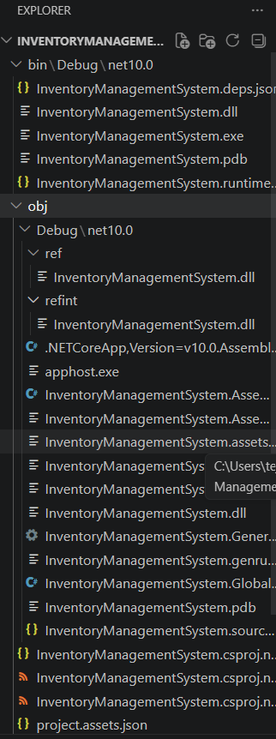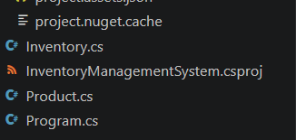
Code :
Program.cs
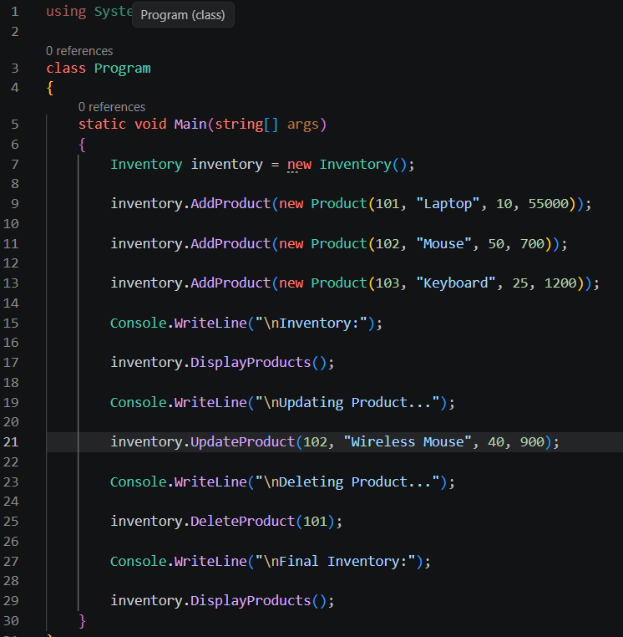
Inventory.cs
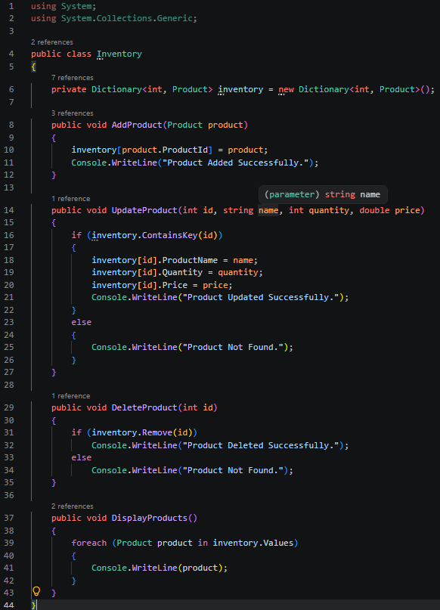
Product.cs
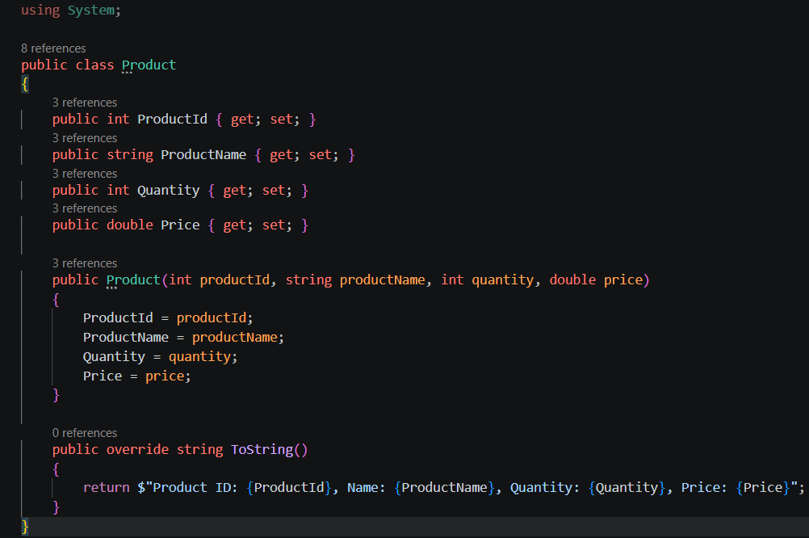
Output:
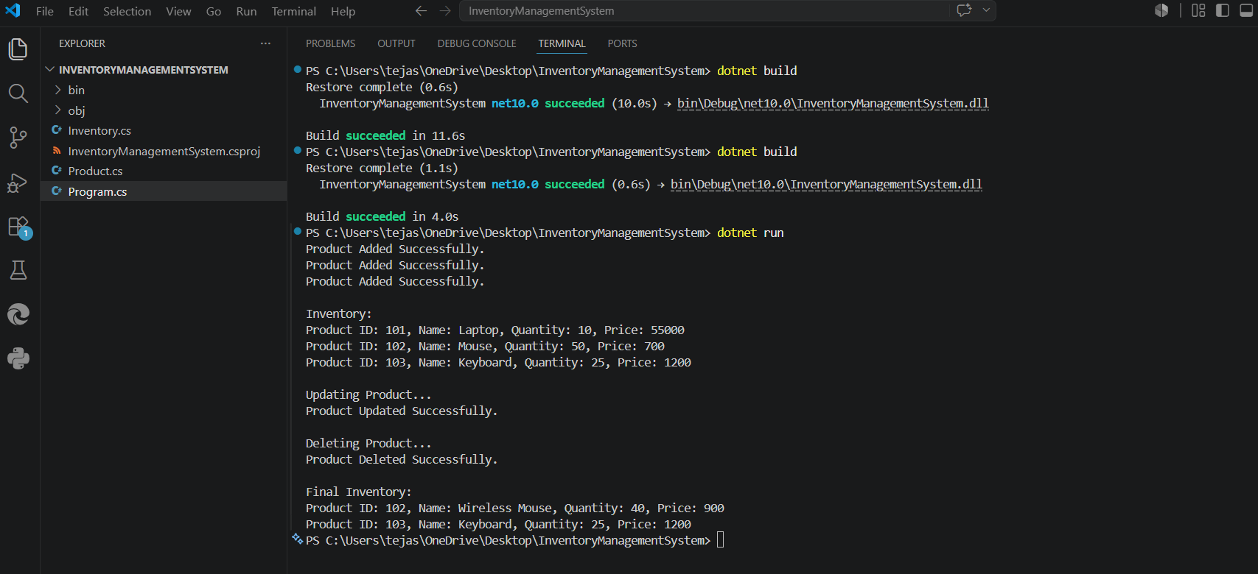

Time Complexity
Operation | Data Structure | Time Complexity
Add Product | Dictionary | O(1) (Average)
Update Product | Dictionary | O(1) (Average)
Delete Product | Dictionary | O(1) (Average)
Search Product | Dictionary | O(1) (Average)
Display All Products | Dictionary | O(n)

Optimization
- Use Dictionary<int, Product>
  - Provides constant-time average complexity for add, update, delete, and search operations.
- Use Product ID as the Key
  - Since Product ID is unique, products can be accessed directly without iterating through the collection.
- Prevent Duplicate Product IDs
  - Check ContainsKey() before adding a new product to maintain data integrity.
- Use SortedDictionary<int, Product> if Sorted Order is Needed
  - Keeps products sorted by Product ID.
  - Time complexity becomes O(log n) for add, update, delete, and search.
- Use a Database for Large Systems
  - For enterprise applications, store products in a database with an index on ProductId to achieve efficient retrieval and scalability.

Conclusion
Using a Dictionary<int, Product> is the most suitable solution for an inventory management system because it provides:
- Fast insertion: O(1) average
- Fast search: O(1) average
- Fast update: O(1) average
- Fast deletion: O(1) average
- Simple and scalable implementation, making it ideal for handling large inventories efficiently.

